## horizontal line

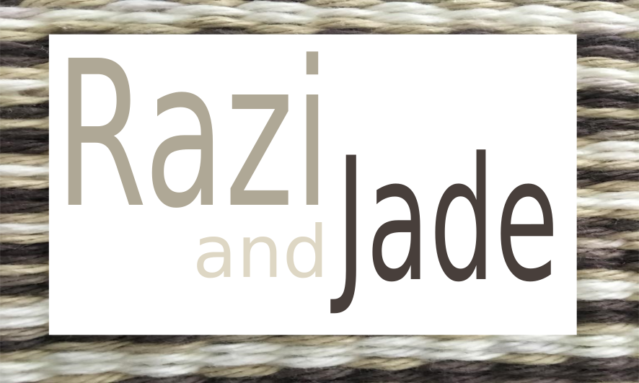

RaziAndJade.com

An eCommerce website for handcrafted knitting projects.

02.17.2018

**─**

David Brigham

Razi and Jade

123 Your Street

Your City, ST 12345

# Overview

(this will be written as though I am addressing the client and since I will be sending this to my wife for whom the site will be made this is not that far fetched.)

We have decided to name the site RaziAndJade.com and have purchased this URL and secured hosting at namecheap.com as well. The name of the site comes from our 2 cats, Razi and Jade. Considering the name we will likely include pictures of the cats, and perhaps even a gallery.

This site will focus on highlighting and selling items created by Sophia. We would also like to include links to good resources for crochet, an about page, a contact page, and perhaps in the future a blog about crochet. The purpose of some of this is self promotion but it also helps to link to other sites and be proactive in a community. If other sites link back to us this makes it more likely that we will get found when people are looking on those sites and on search engines. The end goal therefore should be to build a holistic environment in which our products live alongside information about them, resources for people interested in crochet, a blog about crochet and other crafts, and links to other similar user experiences. The goal will be to sell items of course, but also to show family and friends your projects and to build ourselves into a larger community!

# Goals

The following will be the different parts of the website which I will build in the following weeks and months. Keep in mind that any part of this can be changed to suit your preferences but as always let me know as soon as you can if you would like any changes because while some things are easy to change at any point (like color palette changes) others become more and more difficult as the project moves along (like fundamental structural changes, i.e. position of navigation bar, etc). So without further ado:

**Color Palette**

We generated the color palette from the image you provided for the background. In addition we will add an olive green per your request. This is a screencap of the color palette so far:

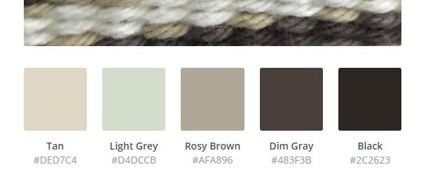

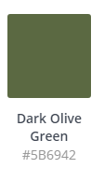

Currently the olive green color is being used for the background in the main text area. I feel that this looks a little “cheap” but is sufficient as a placeholder for the time being. One idea might be to turn the alpha on the green down so that it is very transparent and then use the box shadow effect to make it look slightly recessed into the page. Another would be to treat the green as a highlight color similar to the way I’m using the light blue. The nice thing about this color palette is that by keeping the brightness of the colors toned down it will allow any of your crochet creations that are colorful to really shine in contrast!

Using the more bland colors as the primary palette and then using the light blue color as a highlight really makes for a wonderful contrast. I received multiple compliments from classmates about this effect in our discussion and am overall very pleased with how it was received.

# Pages

1. Home
   1. Landing page with a splash image and links to products
2. Contact page
   1. Just a basic query page in case a customer wants to request an item or ask a question about anything
   2. This would also fill the “feedback page” slot.
3. Order page
   1. This may be a “work in progress” in terms of accepting payment but should have a working form.
4. About me
   1. Whatever basic information about herself and her projects my wife would like to post.
5. Gallery page
   1. This would likely sit in front of the order page as a gallery of products available
   2. There also may be a gallery page for the cats for whom the website is named.
6. Resources / Blog / FAQ or guides for crochet
   1. This would likely be a “would be nice” section for the project rather than a “must have”
   2. Certainly I think it would be nice to link to good resources for crochet.

# Font Specifications

The fonts that I have settled on for the site are “Berkshire Swash” for the headline (<h1>) on the page which is a nice stylistic -- sort of -- quasi cursive looking font as you can see in this image:



The second font which will be used for the main text is called “Coiny”. This font is also currently being used for the navigation. It is a nice friendly rounded looking font that looks good but should also be fairly readable at different sizes, as you can see here:

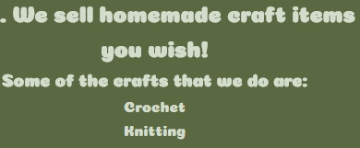

# Milestones

As far as the timetable for completion of the project. Being that class ends in the first week of May it will be completed before then. That said, one of the first things for me to do is to review what I know about Jekyll and make sure that I do want to use it for this project. I’m almost positive I do as it makes the code portable and modular and keeps me from having to repeat code all over the site, as in the DRY! principle of coding (Don’t Repeat Yourself!). My plan generally is to then follow along with the class and use Jekyll to build out each piece of the site as we go over it in class (UL Nav bar, box model, etc). If I get really motivated I may move ahead and finish some of it before it is actually needing to be completed and the workflow may differ from the classes if doing it in Jekyll requires it but I will ensure that I am at least following along with the class if not ahead of where we all are.

# Mock Ups (production version)

The site is now published at RaziAndJade.com. It is fairly scant but it can be seen that the color scheme is in full effect and the images are in place (pictures of my cat which are basically placeholders)

A major concern at this point is that the Nav bar resizes but becomes far too small at a very small size. This is contrary to best practices in terms of being “mobile first”. The remedy will be to add media queries to make the page change to a vertical nav bar at these smaller sizes and to have the images get sent at a small size to save bandwidth. For the moment though this is functional.

Note: I added 3 images to the site which need to have their size adjusted but since this is a matter of needing a media query I’m going to hold off on cropping them down. The idea would be to have different sized images available and then based on the users screen size they would only download an appropriately sized image for their device. Also, the width for the images seems to be stuck at 100% of the view screen size. I’m not sure if this is because the web server is not updating or if there is something wrong with my code. The logo that I created is 640x480 so it should never be larger than that because it looks horribly pixelated (as you can see below).

Front page:

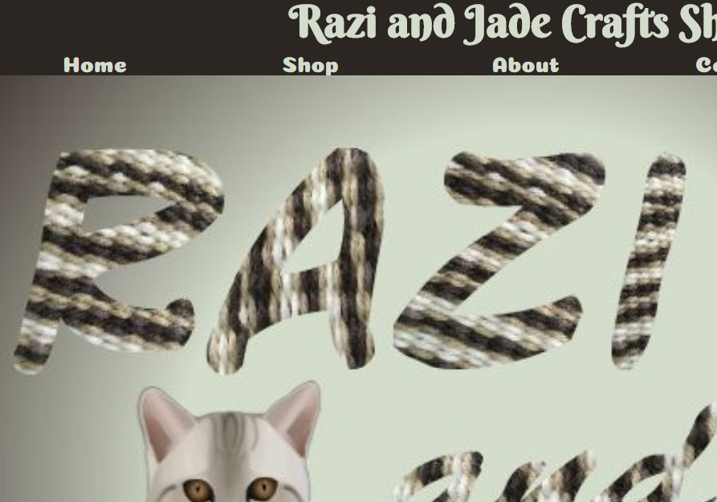

The image above is too large and is therefore pixliated pretty badly.

Likewise this cat probably doesn’t need to be this large. Her ego is big enough as it is….